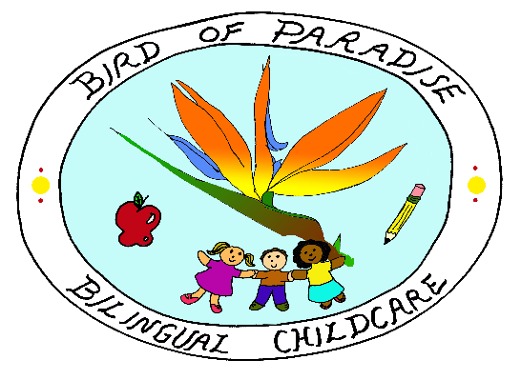
Special Medical and Custodial Conditions

Child’s Name: _______________________________ Birthday: __________________
1. Medical & Special Dietary
Medical Conditions No Yes if Yes, please provide further information
Seizures __ __ ______________________________________________
Asthma __ __ ______________________________________________
Allergic to:
Dairy __ __ ______________________________________________
Nuts __ __ ______________________________________________
Bee Stings __ __ ______________________________________________
Egg __ __ ______________________________________________
Special Dietary Need(s)/Food Restrictions:
Vegetarian __ ___ _______________________________________________
Other: __ ___ _______________________________________________
2. Please list and describe any other medical conditions your child may have:
____________________________________________________________________________________________________________________________________________________________
3. Please list any medications your child is currently taking: __________________________
____________________________________________________________________________
4. Special Instructions
Signs/Symptoms to look for: _____________________________________________________
_____________________________________________________________________________
If signs/symptoms appear, take the following actions: _________________________________
______________________________________________________________________________
List preventive measures: ________________________________________________________
______________________________________________________________________________
PICK-UP PROCEDURES
The pick-up procedures have been developed to keep you child(ren) safe while attending Birds of Paradise Bilingual Childcare. In order for any person other than yourself, the legal parent/guardian, to pick-up your child(ren), the following procedures must be followed:
1. A signed, written authorization indicating the name of the individual picking up and the estimated time of their arrival to Birds of Paradise Bilingual Childcare.
2. Personally inform the childcare provider (Neidy Morales Ramirez).
3. Inform the individual to bring a valid picture ID.
CUSTODIAL
Legal documentation must be submitted
We understand that in special circumstances, only certain individuals are authorized to pick-up your child. Please be aware that in order for Birds of Paradise Bilingual Childcare to enforce any special custodial arrangements. We MUST have legal documentation on file to that effect.
SPECIAL LEGAL ARRANGEMENTS
Please specify and submit legal documentation
________________________________________________________________________________________________________________________________________________________________________________________________________________________________________________________________________________________________________________________________________________________________________________________________________________________________________________________________________________________________________________________________________________________________________________________________________________________________________________

_____________________________________________________________________________
Print name Signature Date
______________________________________________________________________________
Print Name Signature Date

