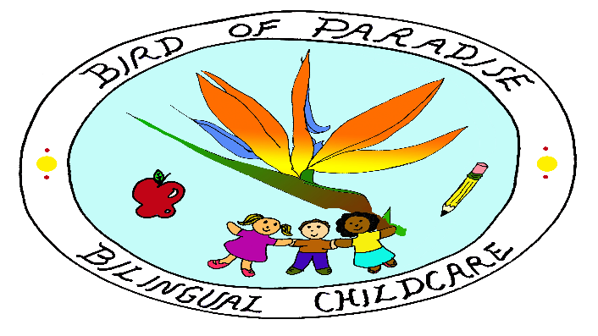
3280 Halcyon Ct. Ellicott City, MD 21043
240-278-5174
bopbilingualchildcare@gmail.com

______________________________________________

PERMISSION SLIP FOR WALKS
                

             I am willing
             I am not willing

to have my child, _____________________________, taken on walks in the area surrounding Bird of Paradise Bilingual Childcare, weather permitting. I understand that my child will be supervised by Neidy Morales Ramirez during walks, and that infants and young toddlers will go in a stroller or walk.

I also authorize any medical treatment in case of an emergency, and agree that I am responsible for any expenses incurred for such treatment.
The undersigned agrees to release, hold harmless and indemnify Bird of Paradise Bilingual Childcare, from all claims, damages or other liabilities for injuries to my son/daughter which are not the result of gross negligence, intentional neglect, or willful or wanton conduct by the childcare.
Emergency Contact: _________________________________________________
Home Phone: ______________________________________________________
Work Phone: _______________________________________________________
Cell Phone: ________________________________________________________

List below any physical conditions the trip supervisors should be aware of to assure all participants have a safe trip (i.e. food allergies) List any medication your child takes routinely or requires in special situations.

__________________________________________________________________

Sign and Date
___________________________________________________
___________________________________________________

