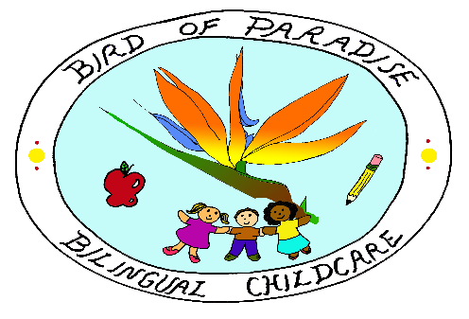
First Day, Policy & Reminders

All Children please bring the forms marked below:
- Emergency card (OCC 1214)
- Medical/Custodial
- Health Inventory (OCC 1215)
- Maryland Immunization Form (DHMH896)
- Allergy or Asthma Plan (if applicable)
- Family Handbook Acknowledgement (sign slip)
- Sunscreen and bug repellent permission slip
- Photo Permission slip
- Walk Permission slip
You must provide the following items for your Child:
- Diapers
- Diapers wipes
- Non-prescription ointments
- Sterilized bottles and nipples including (optional) bottle linings
- Infant formula or breast milk for infants (label it )
- All food for infants and toddlers who are not yet 100% eating table food.
- All food and/or milk for your child if he/she is on a special diet
- Pacifiers, bottles
- Special toys or “Blankets” your child need for napping
- All prescription and over the counter medication (medication form must fill up)
- A complete change of clothes (several during toilet learning)
- Proper outerwear for outdoor play (winter and summer)
(Children with special dietary restrictions: parents must provide snacks and lunch for their kids)
Parents Reminders:
- Sign-in and sign-out your child everyday using our google form link
- Bring your child Thermometer every day to check his/her temperature at the door.

NOTE: You child could not be admitted if any of the previous forms has not been completed and returned. Parent(s) are responsible for notifying as soon as possible of any changes required in any of the above forms.

Parents Signature Date Provider Signature Date

__________________________ _______________________________

__________________________

